(Approx. 712 words)

Pinnacle Studio 12
A Review By Beth Pickering, Sonoma Valley Computer Group, California
www.vom.com/svcg
bethpick (at) emailx.net

This article has been obtained from APCUG with the author’s permission for publication by APCUG member groups; all other uses require the permission of the author (see e-mail address above).

I would love to compare video editing programs and declare Pinnacle Studio 12 the easiest one to use, but to be honest . . . this is the only video editing I have ever done. To be precise: I had a borrowed laptop I had never used before, a few unrelated video clips (not mine), a few pictures (not mine), less than 24 hours to make a demo movie for my presentation, and a history of attracting glitches.

Because Studio 12 is supposed to be easy for a beginner to use I decided to go out of my comfort zone and put this software to the ultimate test: Like many users, I skipped reading the instructions. I have to admit to a little help. I had seen a live demo at a convention and watched some very short informational clips on www.pinnaclesys.com.
The hardest thing I had to do was choosing the options I wanted to use. The closest I got to a glitch was that the video card in my borrowed computer wouldn’t support “Magic Bullet Looks”.

Starting with a “Montage”, I began my quest. I already knew image editing had to be done on the main timeline and that any type of image could be (Graphic 1) used. The numbers showed what image went where. Moving the images around was as easy
as drag and drop. “Undo” and “delete” were also handy. Mixing sections from different Montage themes didn’t cause and problems. Leaving Montage boxes empty didn’t either. The playback only showed an appropriately numbered space. With just a click of a button you can review your creation full screen. When you are editing that particular
section of the orange bar turns green.

There are hundreds of transitions on hand. Picking a category brings up a screen with thumbnail “A/B” boxes. Clicking on one activates the A to B transition so you can see how it looks. After deciding which one to use, you simply drag and drop it into place on the timeline. The other features use thumbnails of the image you are editing (Graphic 2) to show what the final look will be. All you have to do is select the one you want. As you become more skilled you can alter the feature itself. Some (like “Magic Bullet Looks”) have visible boxes to adjust (see above) while others (see Boris Graffiti below) (Graphic 3) have an advanced mode to select. There are prompts where you can enter text and examples to see what it will look like. Any font that is on your computer can be used. Correcting red eye and removing the black bars so your images fill the movie frame can be done with the click of a button. It is possible to interweave up to 18 video tracks in minutes.

Pinnacle Studio 12 has two dedicated sound tracks - one for special sounds and the other for background music. You can import songs to use as is, or you can add them to “Scorefitter” – your own original background music composer. It is as easy to use as the image editors. Several choices have been pre-loaded in the software. You simply pick a style, (Graphic 4) pick a song, pick a version and listen to the result. If you don’t like it, you just start over. The length can be changed by dragging the beginning or ending points. The “song” can be changed at anytime by using the “accept changes” button. also easy. You select the media, then the drop down box choices, and click the “Create” button.

Graphic (5)
I didn’t do it, but I understand that outputting is also easy. You select the media, then the drop down box choices, and click the “Create” button.

My experience with Pinnacle Studio 12 was effortless and fun. Users with no experience can easily make professional looking movies while knowledgeable editors can tweak their movies to an all time high.

Graphic 1
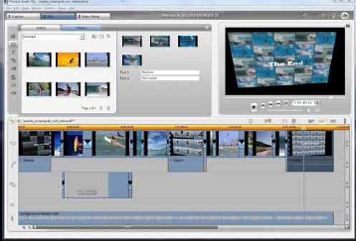

Graphic 2
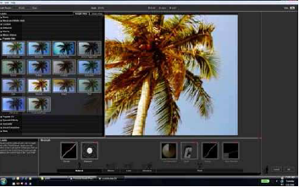

Graphic 3
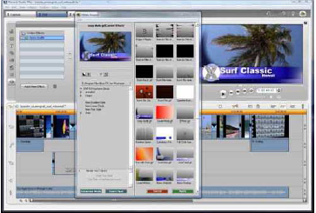

Graphic 4

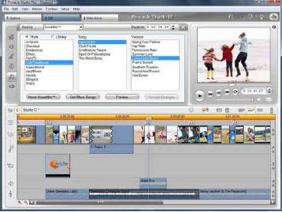

Graphic 5
